# **ADVANCED DEEP LEARNING TECHNIQUES**

Exploring advanced deep learning techniques like CNN-LSTM and attention mechanisms for predicting stock prices is a great idea. Stock price prediction is a complex problem that can benefit from more sophisticated models. Here's a brief overview of how these techniques can be applied:

**1. CNN-LSTM (Convolutional Neural Network - Long Short-Term Memory)**

* **Convolutional layers**: CNNs are typically used for image data, but in the context of stock price prediction, you can use them to identify patterns and features in the historical price data. For instance, you can use 1D convolutions to detect temporal patterns in the time series data.
* **LSTM**: LSTM networks are excellent for modeling sequences and time dependencies. They can capture longer-term dependencies in stock price movements

# **CNN-LSTM Model**

CNN has the characteristic of paying attention to the most obvious features in the line of sight, so it is widely used in feature engineering. LSTM has the characteristic of expanding according to the sequence of time, and it is widely used in time series. According to the characteristics of CNN and LSTM, a stock forecasting model based on CNN-LSTM is established. The model structure diagram , and the main structure is CNN and LSTM, including input layer, one-dimensional convolution layer, pooling layer, LSTM hidden layer, and full connection layer.

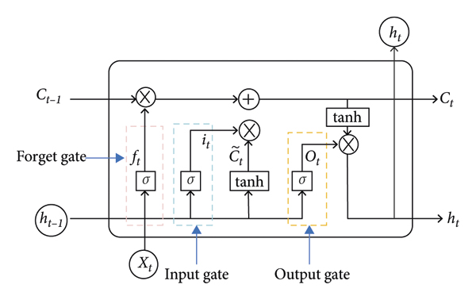

FIGURE 1:CNN -LSTM structure diagram

* **CNN-LSTM Training and Prediction Process**

The CNN-LSTM process of training and prediction

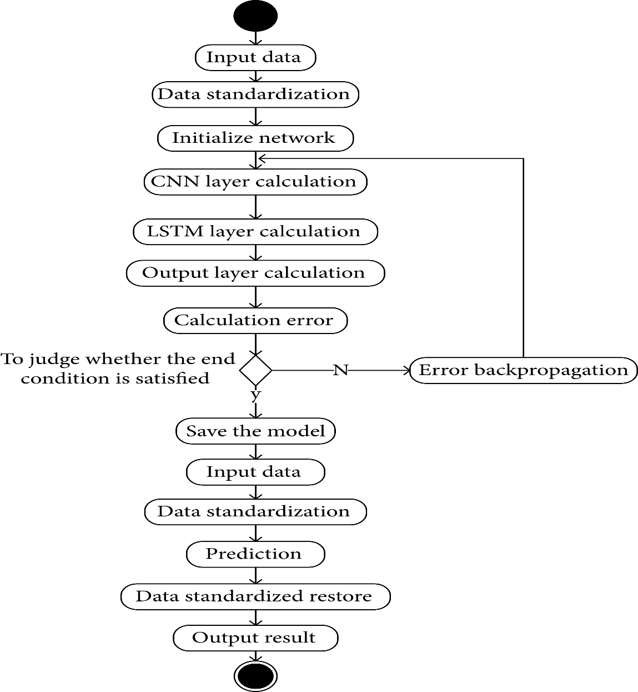

Activity diagram of CNN-LSTM training and prediction process

The main steps are as follows:

(1)Input data: input the data required for CNN-LSTM training.

(2)Data standardization: as there is a large gap in the input data, in order to train the model better, the *z*-score standardization method is adopted to standardize the input data, as shown in the following formula:

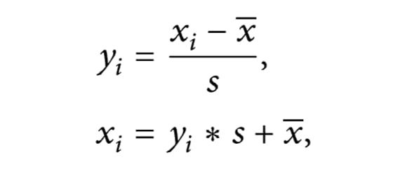

Where(yi)  the standardized value,  (xi)is the input data,x is the average of the input data, and *s* is the standard deviation of the input data.

* Initialize network: initialize the weights and biases of each layer of the CNN-LSTM.
* CNN layer calculation: the input data are successively passed through the convolution layer and pooling layer in the CNN layer, the feature extraction of the input data is carried out, and the output value is obtained.
* LSTM layer calculation: the output data of the CNN layer are calculated through the LSTM layer, and the output value is obtained.
* Output layer calculation: the output value of the LSTM layer is input into the full connection layer to get the output value.
* Calculation error: the output value calculated by the output layer is compared with the real value of this group of data, and the corresponding error is obtained.
* To judge whether the end condition is satisfied: the conditions for the end are to complete a predetermined number of cycles, the weight is lower than a certain threshold, and the error rate of the forecasting is lower than a certain threshold. If one of the conditions for the end is met, the training will be completed, update the entire CNN-LSTM network, and go to step 10; otherwise, go to step 9
* Error backpropagation: propagate the calculated error in the opposite direction, update the weight and bias of each layer, and go to step 4 to continue to train the network.
* Save the model: save the trained model for forecasting.
* Input data: input the input data required for the forecasting.
* Data standardization: the input data are standardized according to formula ([8](https://www.hindawi.com/journals/complexity/2020/6622927/#EEq8)).
* Forecasting: input the standardized data into the trained model of CNN-LSTM, and then get the corresponding output value.
* Data standardized restore: the output value obtained through the model of CNN-LSTM is the standardized value, and the standardized value is restored to the original value. As shown in the following formula ([9](https://www.hindawi.com/journals/complexity/2020/6622927/#EEq8)).

 where  is the standardized restored value,  is the output value of the CNN-LSTM,  is the standard deviation of the input data, and  is the average value of the input data.

* Output result: output the restored results to complete the forecasting process.
* **Comparison of the predicted value and the real value for CNN-LSTM.  
  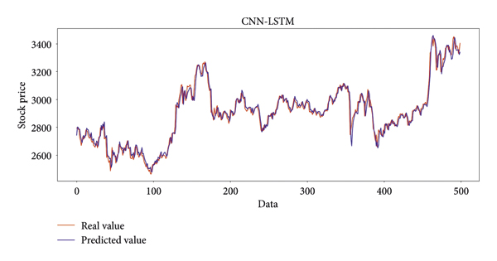**

The combination of CNNs for feature extraction and LSTMs for sequential modelling can be effective in capturing both short-term and long-term dependencies in stock price data.

**2. Attention Mechanisms:**

* Attention mechanisms are particularly useful when dealing with sequential data like stock prices. You can implement various types of attention mechanisms, such as self-attention or scaled dot-product attention.
* These mechanisms help the model focus on relevant time steps or features in the input data, allowing it to assign different levels of importance to different elements in the sequence.

Here are some steps to follow when implementing these advanced techniques:

1**. Data Preparation:**

* Clean and preprocess your historical stock price data.
* -Create input sequences and target variables for training and testing.

**2. Model Architecture:**

* Design a neural network architecture that incorporates CNN-LSTM layers or attention mechanisms.
* Experiment with different hyperparameters, layer configurations, and network depths.

**3. Training:**

* Train your model using historical data, taking care to split it into training and validation sets.
* Implement a loss function suitable for regression tasks (e.g., Mean Squared Error).

**4. Evaluation:**

* Evaluate your model's performance on a test dataset.
* Use metrics like Mean Absolute Error (MAE) or Root Mean Square Error (RMSE) to assess accuracy.

**5. Hyperparameter Tuning:**

* Fine-tune hyperparameters to improve model performance.
* Consider techniques like grid search or random search.

**6. Regularization:**

* Implement regularization techniques such as dropout and batch normalization to prevent overfitting.

**7. Ensemble Methods:**

* You can also consider combining multiple models or using ensemble techniques to further improve predictions.

**8. Backtesting:**

* Simulate trading strategies based on your predictions to assess their effectiveness.

Remember that predicting stock prices is a challenging task, and there are no guarantees of accuracy. It's crucial to consider factors like market sentiment, news, and external events that can influence stock prices, which your model may not capture.

Additionally, be cautious when using deep learning for financial applications, as the risk and complexity involved in stock trading are substantial. Always make data-driven decisions and consult with financial experts when making investment choices.

SUBMITTED BY,

SRUDHINA M S

au720921244053

7209 JCT college of engineering and technology